SUBJECT: **OBJECT ORIENTED SOFTWARE ENGINEERING**

TOPIC: **SMART DISEASE PREDCTION SYSTEM**

MADE BY:

**SHUBHAM 01516401519**

**MAYANK KUMAR VERMA 02116401519**

**GAURAV KUMAR TIWARI 04716401519**

**VINAY TIWARI 02316401519**

**Problem Statement:**

Nowadays It has become a really difficult task to arrange doctor’s appointment immediately for some health issues and it is even more difficult for someone who lives in rural area. Even if one gets appointment, it is another task to take a leave from your busy schedule to visit the doctor. To solve these issues and make doctor appointments and treatment easier and less time consuming, here we propose a system that allows users to get instant guidance on their health issues through an intelligent health care system online. The system is fed with various symptoms and the disease/illness. The system allows user to share their symptoms and issues. It then processes users’ symptoms to check for various illness that could be associated with it.

It also gives the user an option to have an appointment online immediately. Online appointment is much more affordable and less time consuming.

The system predicts disease using pre-existing data and taking inputs from the user like Personal Details, Medical Background, BMI, etc. and then symptoms and then the program matches the symptoms with disease from database to finally show the result.

Even then there are so many people who cannot afford to have a treatment of chronic diseases; therefore, it will also help in connecting with some government or non-government organisations who are willing to help.

System will not only be helpful in getting instant guidance on their health issues but will also provide useful information on latest spreading diseases in the country and how to prevent it.

**Use case Diagram**

**For USER/PATIENT:**

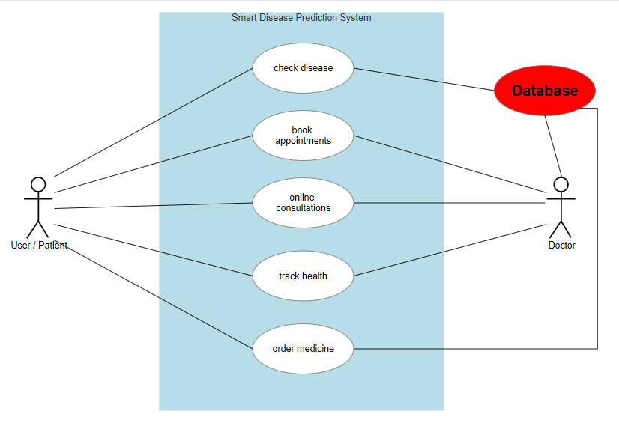

**For DOCTOR/HEALTH PROFESSIONAL:**

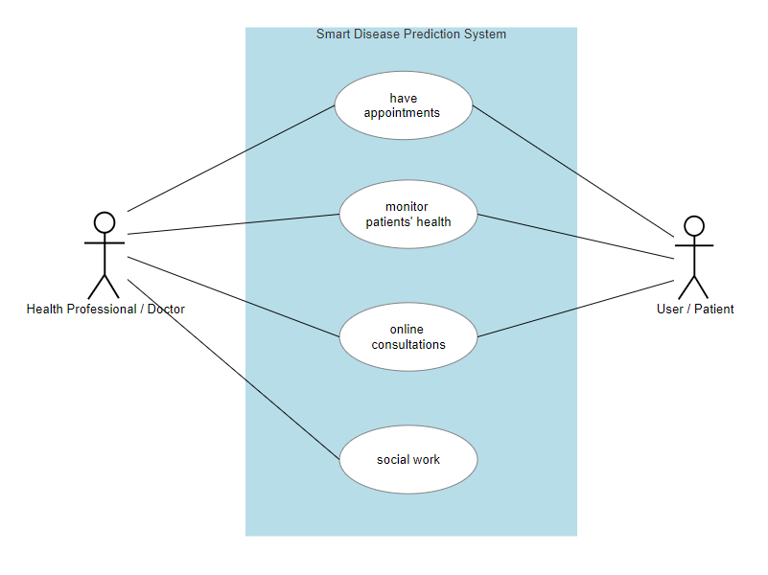

**Use-case Template:**

Use-case**: check disease**

|  |  |
| --- | --- |
| Actor | Primary Actor: User/Patient  Secondary Actor: None |
| Description | This use case will predict disease according to the input(symptoms) provided by the actor and show the results along with some recommendations of doctors that the user can make contact immediately via online medium and also making appointment offline. |
| Precondition | Actor must have a valid Email ID |
| Basic Flow | Actor will fill in details like symptoms and some medical background and then the system will match this data from the database to provide the most accurate result. |
| Alternate Flow | Actor provides wrong Email ID or password then the system will be redirected to same page again. |
| Exception Flow | If Actor provides wrong Email or password for more than 10 times in an hour then the account will be temporarily suspended and can only be accessed after contacting with the customer care executive. |

Use-case: **monitor patients’ health**

|  |  |
| --- | --- |
| Actor | Primary Actor: Health Professional/Doctor  Secondary Actor: User/Patient |
| Description | This use case will help doctor in monitoring patients’ health and making changes in his/her treatment easier and less time consuming. Making the treatment more effective. |
| Precondition | Actor must have a valid Email ID |
| Basic Flow | Doctor will fill in details of the patient then the system will show the current status of the patient, past treatments of diseases and also the diet plan of patient, in this way treatment of patients can easily be tracked. |
| Alternate Flow | Actor provides wrong Email ID or password then the system will be redirected to same page again. |
| Exception Flow | If Actor provides wrong Email or password for more than 10 times in an hour then the account will be temporarily suspended and can only be accessed after contacting with the customer care executive. |